**Connecting** * Connect your laptop to a high-speed connection. If you are using a wireless connection, logon to the computer, then connect to the wireless network. Cable Modem service, DSL service, Hotel provided networks and Public wireless are all considered viable high speed connections.

1. Log on to your computer with your CAC card.
2. Make sure you have an Internet connection before you connect VPN.
   1. Open Internet Explorer. Click Tools, Internet Options, Connections tab, LAN Settings button…
   2. Uncheck “Use a proxy server for your LAN”. Click OK out of all the boxes.
   3. Refresh the page, click Home, or try any website. You should now have access.

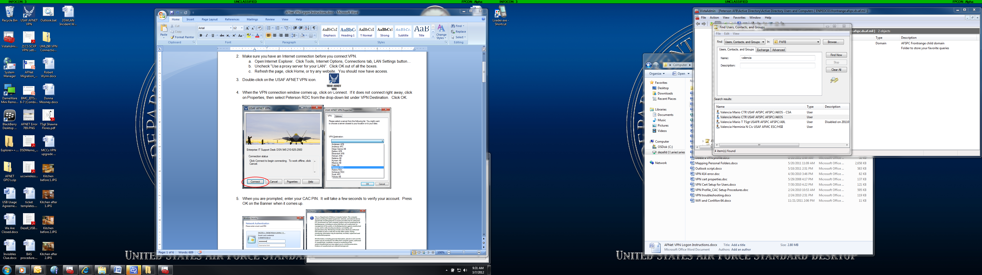

1. Double-click on the USAF AFNET VPN icon.
2. When the VPN connection window comes up, click on Connect. If it does not connect right away, click on Properties, then select Peterson RDC from the drop-down list under VPN Destination. Click OK.

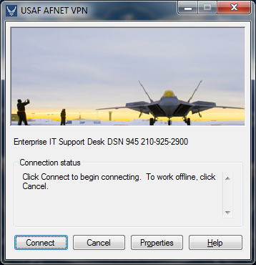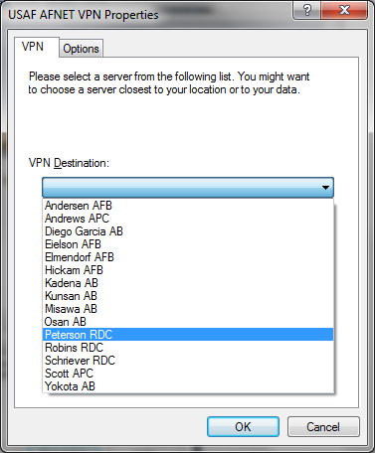

1. When you are prompted, enter your CAC PIN. It will take a few seconds to verify your account. Press OK on the Banner when it comes up.

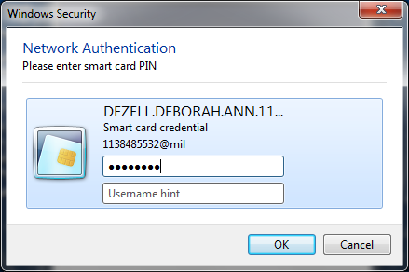 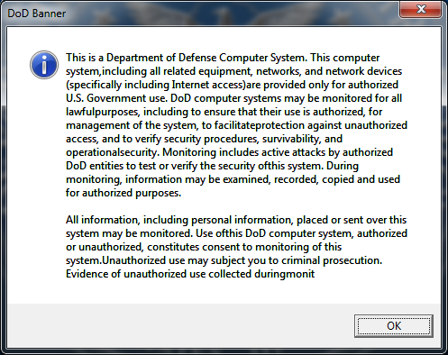

1. You are now connected to VPN.
2. You should be able to open your e-mail and connect your network drives.
3. 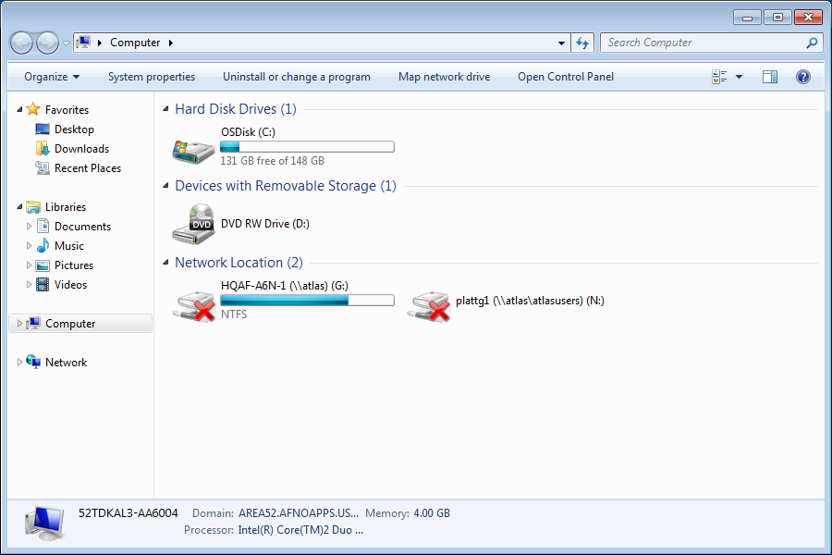You will need to double-click on your drives to connect them. If they have a red X on them, they are not connected.
4. If you get prompted for a password, select your Smart Card credentials and enter your PIN.

**Disconnecting** * DON’T FORGET TO DISCONNECT FROM VPN BEFORE YOU SHUTDOWN.

1. Open the VPN icon and click on the Disconnect button. Or click on the connections icon in the system tray and disconnect from the VPN connection.

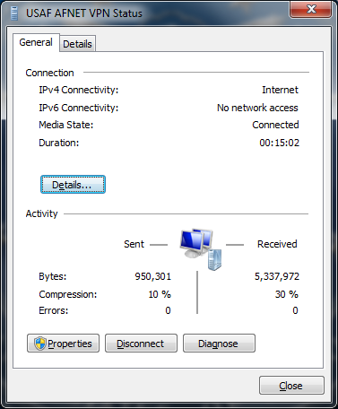 or 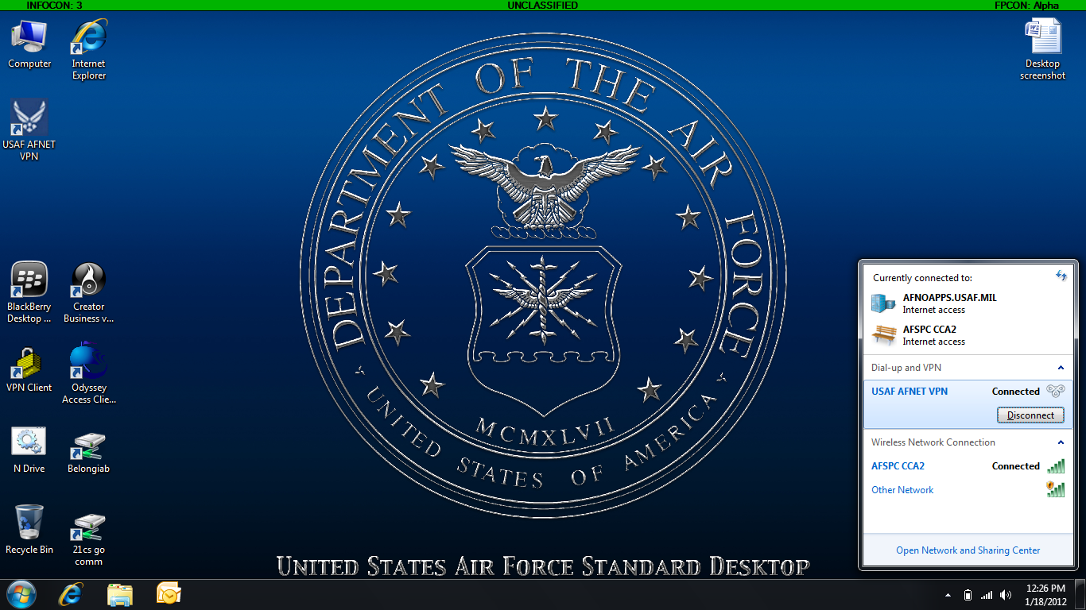

**Keeping up to Date**

1. Once you have established a VPN connection, click on the Microsoft (Start) button and type in **gpupdate /force** in the Search field and press Enter.

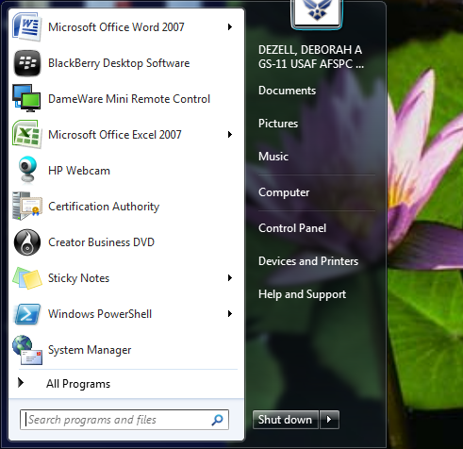

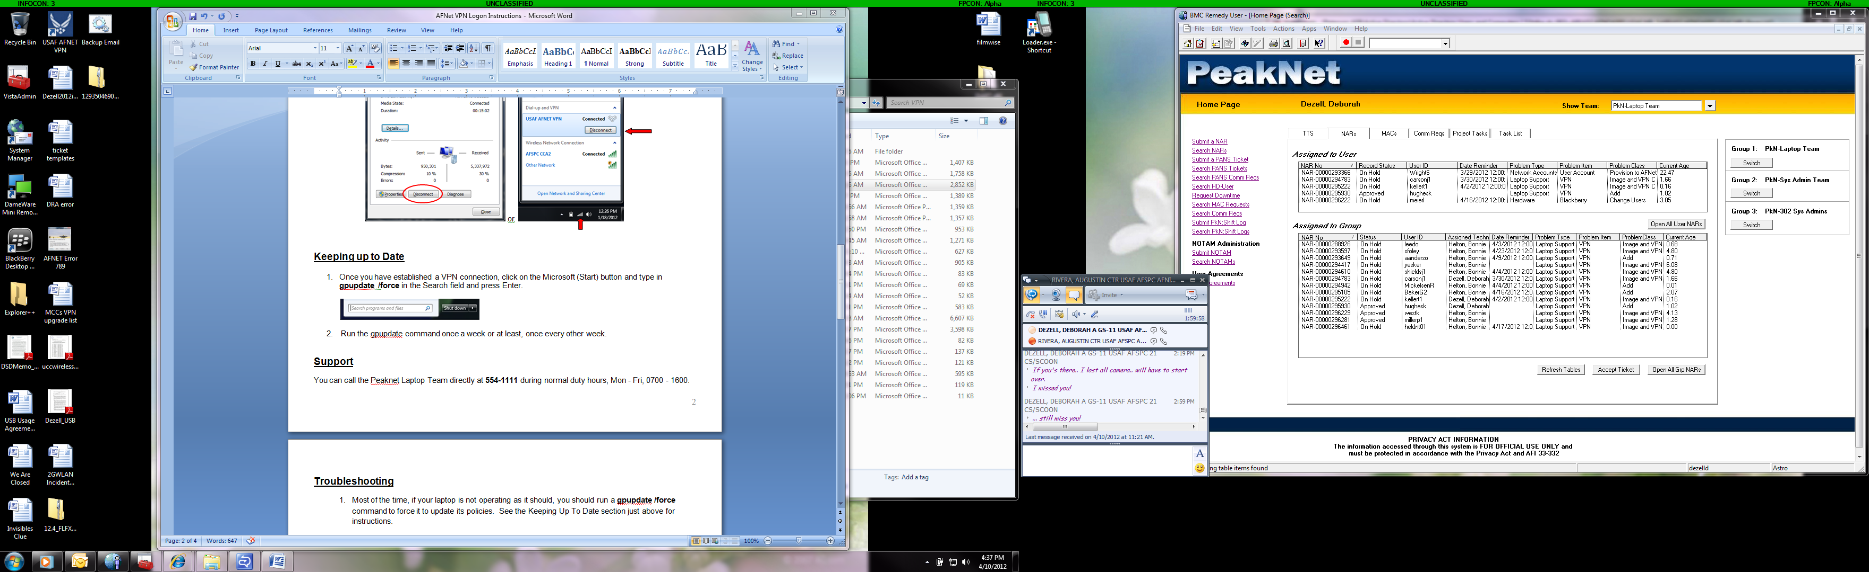

1. Run the gpupdate command once a week or at least, once every other week.

**Troubleshooting * You can open Outlook without VPN, just an internet connection**

1. Most of the time, if your laptop is not operating as it should, you should run a **gpupdate /force** command to force it to update its policies. See the Keeping Up To Date section for instructions.
2. **Error 789**: If you get this when trying to connect to VPN, reboot the computer, wait about 15 minutes and then try again. If it still doesn’t let you connect, change the server you are connecting to from Peterson RDC to another one such as Schriever RDC or Scott APC. If you get connected, run the gpupdate /force command from the previous step. When it is done, reboot then try to connect to Peterson again.



1. If you are unable to connect to VPN, but you do get an Internet connection, you can still access your e-mail through **OWA (Webmail)**. Just go to <https://peterson.mail.us.af.mil>/ and when it prompts for a certificate, pick the one that has e-mail in the issuer name.
2. If your network drives do not show up, you will have to manually map them.
   1. Click on the round Microsoft (Start) button and go to Computer.
   2. Click on Map Network Drive from the menu.
   3. Click on the drive letter you want to use and then type in the path for your drive. You will have to know the exact path, the Browse button will not work in VPN.
   4. Click Finish.

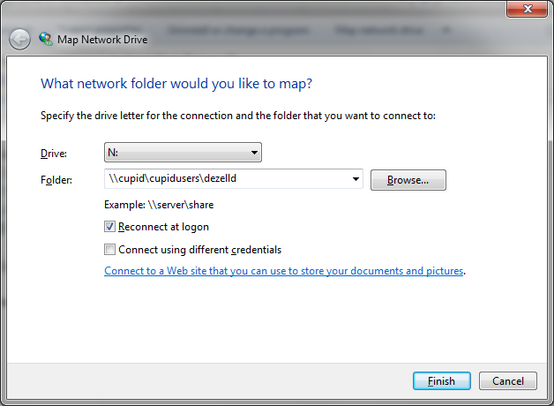

1. If the Internet does not come up after you VPN, or if your e-mail takes forever to update, you may need to set the proxy for VPN.
   1. Open Internet Explorer. Click Tools, Internet Options, Connections tab, LAN Settings button…
   2. Click on the Advanced button and copy everything in the Exceptions block.

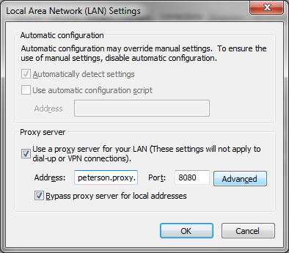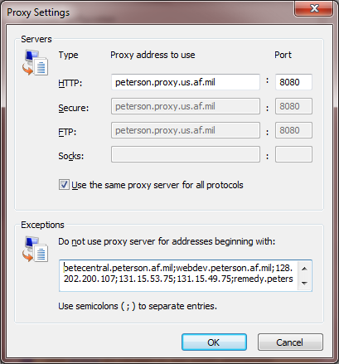

* 1. Click cancel twice to return to the Internet Options window.
  2. In the Dial-up and Virtual Private Network settings, make sure USAF AFNET VPN is highlighted and click the Settings button…
  3. Check both boxes under “Use a proxy server for this connection”.
  4. Type in **peterson.proxy.us.af.mil** in the Address block and **8080** in the Port block.

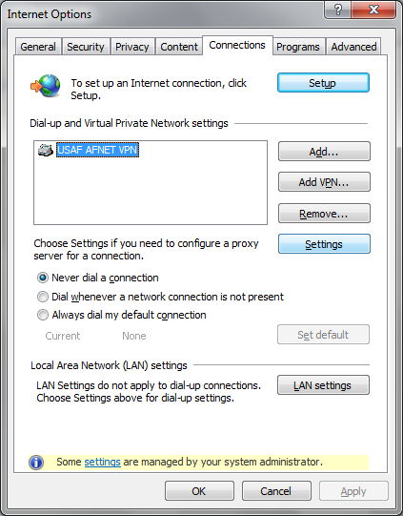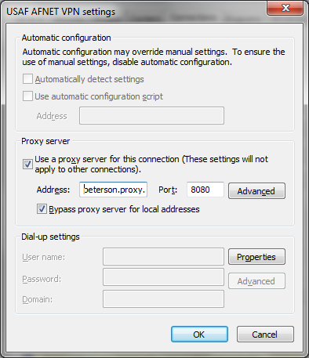

* 1. Click on the Advanced button.
  2. Paste the addresses you copied from step b into the Exceptions block.
  3. Click OK out of all the boxes